**CIS 4930 Artificial Intelligence**

Assignment 2

Due date: March 5 at 11:59pm

**Problem 1 (10 points)**

This map shows approximate mean driving times (in hours) between pairs of cities. For each of the following graph search strategies, work out the order in which states are expanded, as well as the path returned by graph search. In all cases, assume ties resolve in such a way that states with earlier alphabetical order are expanded first. The start and goal states are Warsaw and Rome, respectively. Remember that in graph search, a state is expanded only once.

The distance from Warsaw to Munich is 15, from Warsaw to Odesa is 6, from Warsaw to Budapest is 9, from Munich to Budapest is 12, from Munich to Venice is 3, from Munich to Rome is 15, from Rome to Venice is 6, and from Odesa to Venice is 14.

.

|  |  |
| --- | --- |
| **City** | **h(n)** |
| Warsaw | 30 |
| Budapest | 12 |
| Munich | 3 |
| Odesa | 20 |
| Rome | 0 |
| Venice | 3 |

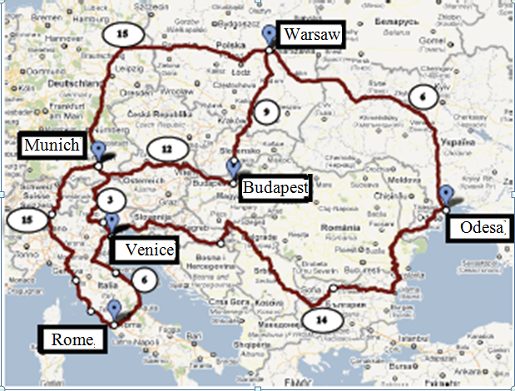

1. Greedy search with the given above heuristics (4 points)
2. A* search with the same heuristics. (4 points)
3. Is the heuristic admissible? Consistent? Briefly justify your answers. (2 points)

**Problem 2. (15 points)**

Suppose that the cost of a move in the 8-puzzle is equal to the number of the moved tile. That is, the cost of moving tile 1 is $1, the cost of moving tile 2 is $2, and so on. Calculate the heuristics, the number of displaced tiles, for each states and implement the algorithm A* that finds a cheapest solution; it should read a start state from a tile, and print out a cheapest sequence of moves that leads to the goal state given in Figure below:

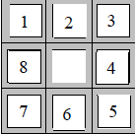

Use the programing language of your choice.

You may assume that the puzzle always has a solution; that is, the program does not have to deal with unsolvable states. The format for encoding start states is as follows:

<tile> < tile > < tile >

<tile> < tile > < tile >

<tile> < tile > < tile >

Each <tile> is a digit from 0 to 8, where 0 marks the blank space, and the other digits are real tiles. For example, the following file encodes the start state:

7 2 4

5 0 6

8 3 1

Sample file 1:

1 3 4

8 0 2

7 6 5

Solutions: The shortest path cost =11

Sample file 2:

1 3 4

8 0 6

7 5 2

Solution: The shortest path cost = 30

**Submitting your assignment**

* Submission via Canvas Assignment.
  + It is your responsibility to submit these assignments in a timely fashion.
* All files should be zipped together.
* There should be a readme file explaining in detail the exact steps to be taken to compile and execute the code files and the title page
* In case of any code errors, partial credit may be offered based on the code and documentation.
* A report that presents the performance evaluation of your solution.

**Late Submission Policy**

* Late work will be not accepted.

**Rubric for Assignment 2**

**Problem 1 (6 points)**

1. [4/]
2. [4/]
3. [2/]

Don’t copy others’ work. You can google and read tutorials to understand the concepts, and can provide reference.

**Problem 2 (15 points)**

* Compile, run and test (15 points)

[5/] code compile

[5/] Run the program

[1/] Test case 1

[1/]Test case 2

[1/] Another Test case

[2/] Report